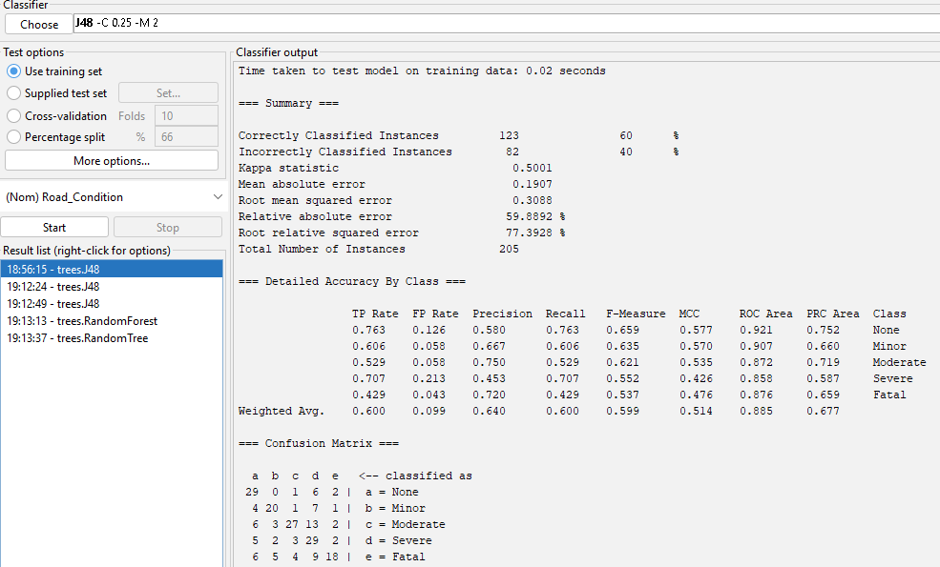

**Decision Tree Analysis Summary**

**Key Findings:**

* **Weather is the primary factor** influencing accident severity.
* **Stormy and Rainy conditions** increase accident severity, especially for Motorcycles and Buses.
* **Slippery and Under-Construction roads** contribute to higher injury risks.
* **Salgaa and Sachangwan** are high-risk locations.

**Insights & Recommendations:**

* **Enforce speed restrictions** in adverse weather conditions.
* **Improve road maintenance** to reduce slippery and pothole hazards.
* **Enhance safety measures** for motorcyclists and public transport vehicles.
* **Implement accident hotspot interventions** in high-risk locations.

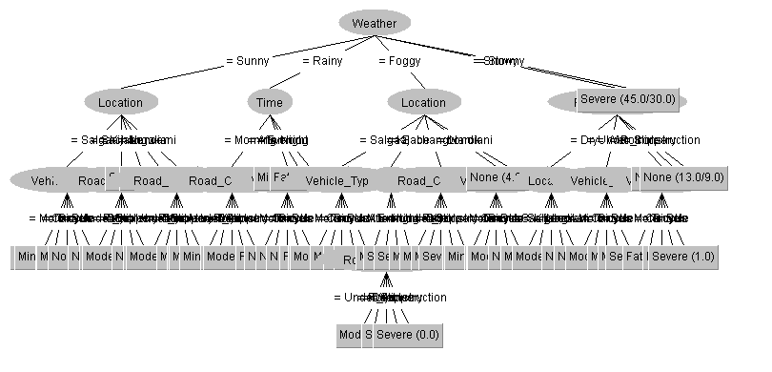

**Policy Recommendations**

**Based on the insights derived from the dataset, the following policy recommendations can improve road safety:**

**· Infrastructure Upgrades: Repairing potholes, improving road drainage, and implementing better lighting in accident-prone areas.**

**· Traffic Regulations: Enforcing speed limits, implementing traffic calming measures in hotspots, and increasing police presence.**

**· Public Awareness Campaigns: Educating drivers on the risks of adverse weather conditions and the importance of vehicle maintenance.**

**· Smart Traffic Management: Utilizing AI-based traffic monitoring systems to predict and prevent accidents in high-risk areas create a safer road environment, reducing accident severity and fatalities.**